**Project Name: NaturoPet**

Sprint 1 focuses on user stories in Epic HomePage

Backlog:

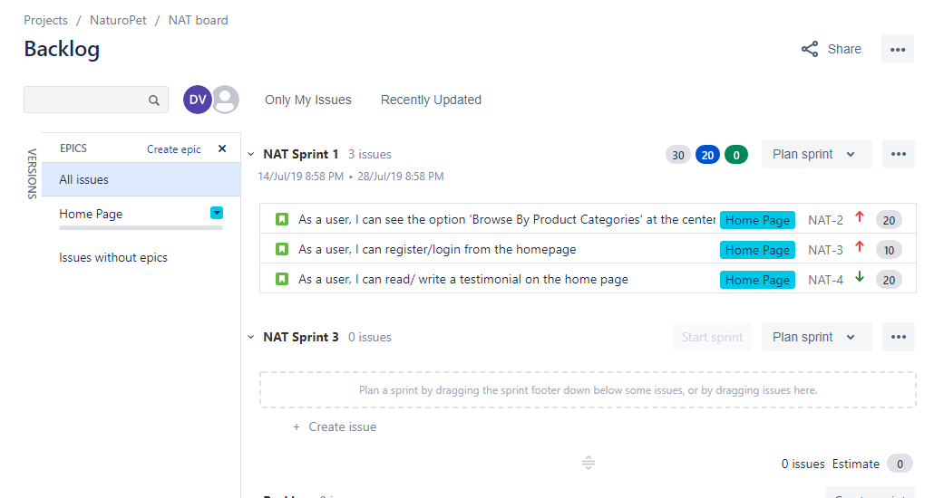

User stories:

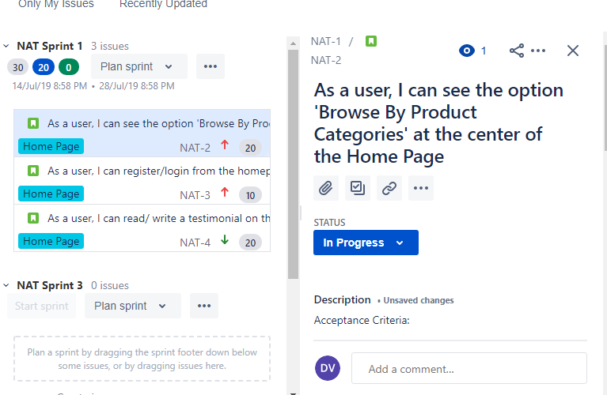

Acceptance criteria for user-story shown above (‘Browse By Product Categories’):

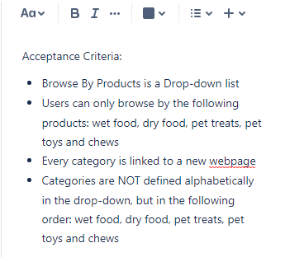

Definition of Done for above shown user story:

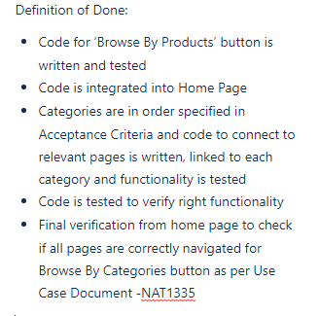

Sprint 1:

